================= Beginner Module =========================

1. Introduction of python and features of python
➤ What is Python?
Python is a high-level programming language, which means it is closer to human language and easy to understand.
- High-level language → Easy to read, write, and maintain
- Low-level language (e.g., Assembly) → Closer to machine language and hardware

2️⃣ Features of Python
1. Object-Oriented Language (OOP)
Python supports object-oriented programming.
- Uses classes and objects
- Useful for handling real-world entities
- Helps in designing scalable and reusable applications

2. Interpreted Language
- Python runs code line by line using an interpreter
- Easier debugging
- Faster development
- May be slightly slower for very large applications compared to compiled languages

3. Dynamic Typing (Dynamic Semantics)
- No need to explicitly declare variable types
- Just define the variable — Python assigns memory automatically
- Memory management is handled internally by Python
Example:
x = 10
name = "Krithiksha"

4. Portable Language
Python is platform-independent.
- Code written in Windows can run on Linux or macOS
- No major modifications required

5. Integrated Language
Python can be integrated with other languages like:
- C
- C++
Used for performing complex or high-performance tasks.

6. General-Purpose Language
Python is used in multiple domains:
- Web development
- Cloud & deployment
- Scientific computing
- Artificial Intelligence
- Automation
- Data analysis
- Software development

7. GUI Libraries
Python provides GUI frameworks such as:
- Tkinter
- PyQt
- PySimpleGUI
These are used for building desktop applications.

8. Frontend & Backend Development
Python can be used for:
- Frontend (Desktop Applications) → Using PyQt, Tkinter
- Backend (Web Applications) → Using Django

9. Glue Language
Python is called a glue language because:
- It easily connects with other languages
- It integrates well with different frameworks
- It has a large ecosystem of libraries

10. Simple Syntax
- Easy to learn and implement
- Uses indentation to structure code
- Improves readability

11. Libraries & Modules
Python provides:
- Built-in libraries
- Third-party libraries
They contain pre-written code to perform common tasks efficiently.

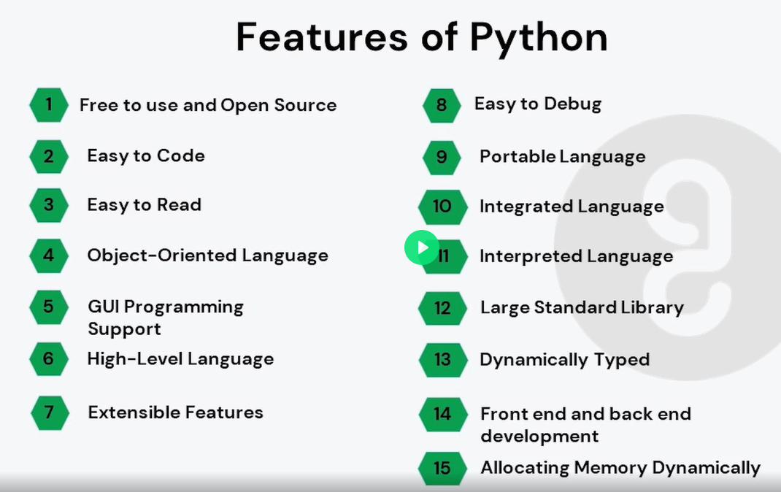

Auto memry allocation VS dynamically typed ???
Auto Memory Allocation
Python uses automatic memory management, meaning developers do not manually allocate or deallocate memory for objects, unlike languages such as C or C++.
- Mechanism: Python's memory manager handles the allocation and deallocation of memory on the heap using two primary mechanisms:
  - Reference Counting: The interpreter keeps a count of how many variables or objects are referencing a specific object in memory. When this count drops to zero, the memory is immediately reclaimed.
  - Garbage Collection: A separate, generational garbage collector runs periodically to identify and clean up memory cycles (e.g., two objects referencing each other) that reference counting cannot resolve.
- Advantage: This system simplifies coding and helps prevent common errors like memory leaks and dangling pointers, allowing developers to focus on program logic.
Dynamic Typing
Python is a dynamically typed language, meaning that the type of a variable is determined at runtime based on the value assigned to it, rather than requiring explicit type declarations in the code.
- Mechanism: In Python, variables are not containers with a fixed type; they are references or labels pointing to objects in memory. The object itself carries the type information.
- Flexibility: A single variable can be reassigned to values of different types during program execution without a type error:
python
x = 10 # x refers to an integer object
x = "hello" # x now refers to a string object
- Advantage: Dynamic typing allows for more flexible and rapid development, as it reduces boilerplate code and makes the language more accessible to beginners.
Mechanism | What It Handles
Reference Counting | Normal unused objects
Garbage Collector | Circular references

2. PVM, Frozen Binaries & Memory Management

